Registration Sign-up Form:

Shipping Address vs Billing Address:
On the Account Registration form the system asks for an Address but it does not specify if it is a Billing or Shipping Address. This means that any order placed will force the user to use this address as BOTH the Billing and Shipping Address:
- Need the New Customer Registration form to allow the customer to enter both a Billing and Shipping address during sign-up
  - We can include the option that uses a ‘click here if billing is the same as shipping’ button so the system will automatically update the billing address based on the shipping address entered.
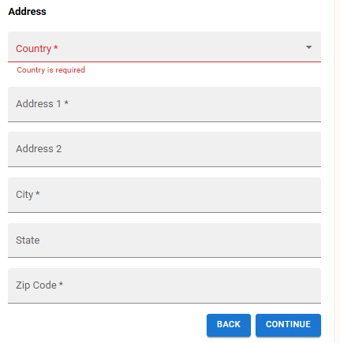
Address labels should be updated to specify Shipping Address or Billing Address.

Adding a button at the bottom or top of the Shipping Address section to auto-fill the Billing Address if selected.

Registration form use of space
The Registration form is using a full page on the screen but the vast majority is empty space
- Instead of using a full page with wasted space adjust the registration form to either better use the space
  - Move multiple pages onto one page (instead of having to ‘continue’ through three pages
  - OR make it more of a pop-up type format that would look better on the screen but also maintain mobile compatibility.
  - Add graphics / text to encourages the customer during the process
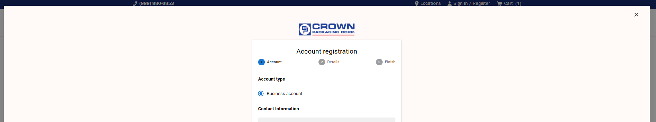
Dave team will put together some suggestions and come back to us.

Duplicated request for Email address:
On page 1 of the new account setup it asks for Email, but then on page 2 it asks for a ‘company email’.
- For our setup, users should use their company email to log into the account and won’t need two separate ones
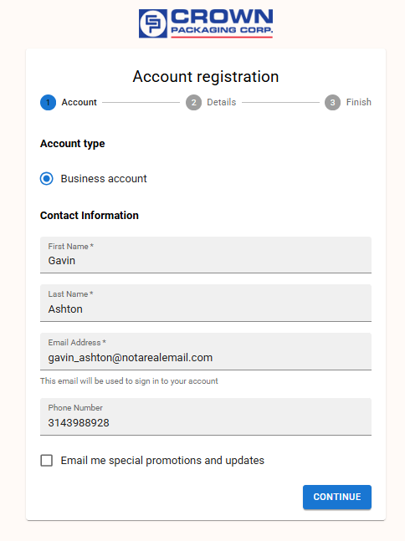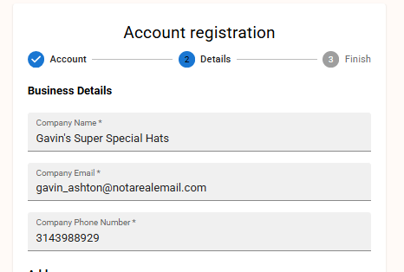

Address Validation (USPS)
The system will allow us to enter any address into the system and will accept it.
- Is there a way to add USPS address validation onto the registration form to try and avoid accidently user entry errors up front.

Tax Exempt Form submission
Many of the customers we have will be tax exempt and so they will need to provide us the form. We are moving to a new process where Vertex will store the Tax Exempt forms and send back the Tax Status on the order. OPEN ITEM
- Ability for the new customers to submit the form upon account creation (if desired)
- Ability for the new customer to submit the form through their customer portal (account)
- Ability for the new customer to submit at time of ordering
  - Admittedly, this may be too late but something to consider
There was some discussion that there may be a Vertex App that we can use to facilitate this but more research is needed about how we want to do this.

Account Setup:
We will need to create a ‘New Customer’ setup / configuration that will limit what the user is able to do. This would affect primarily key functions like Payment Options and Shipping Options.
Solution for this could be to create a ‘New Customer’ setup or to adjust the existing customers and default would be the following restricted access.
A key consideration is that we will want to move the customer from the New Customer permissions and ‘update’ them all allow the full payment / shipping options at some point.

Payment Options
New customers should be restricted to only allow them to pay with a Credit Card / ACH
- The ‘New Customer’ configuration should only allow them the option to choose a credit card or US Bank Account from the payment options
  - Customer should still be allowed to save their credit card.

Shipping Options
New customers should be restricted to the basic shipping options
- New Customers should only see the following options:
  - Ground (UPS)
  - LTL (with the options for lift gate / inside delivery)
  - Truck Load

Additional Changes:

Home Page Setup
New users will have access to the Featured Product catalog but will also see the ‘Your Items’ section
- Need to change the messaging when there is no customer category. (Customer Catalog)
  - Aaron and I can change this messaging.
The home page banner has messaging and a button that points a user to the Sign-in page, even if they are already logged in.
  - OPEN ITEM – Aaron and I can change this messaging.

Account Access:
At account registration the person signing up is setup as the Administrator of that company (rather than a Sr. Buyer) This should be fine – no changes needed here unless we need to add a designated ShipperHQ Group or something like that so they only see the more limited options
- OPEN ITEM - Is this ok, or should we change to be a Sr. Buyer
  - Admin will allow the editing of the address information BUT if we have an automated process to create / update addresses that should be ok.
    - Admin cannot create new addresses (at least not with the current setup)
  - Can we, upon JDE account setup, update their access to Sr. Buyer from Admin….do we need to do this?

